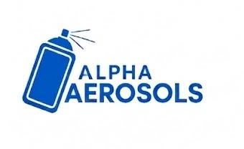 | Alpha Aerosols  Production Job Card | Doc #: AER-JC-001  Date: ____________  Revision: 00
1. JOB / ORDER DETAILS
POF # |  | Date / Shift
Customer |  | Product / Can Size
Order Qty Cans) |  | Artwork Ref.

2. MATERIAL ISSUE
S#. | Material Description | Item Name | Item Code | Total Required Qty | Unit
1 | Aluminum Slug |  |  |  | kg
2 | Lubricant |  |  |  | kg
3 | Cleaner / Wash Chemical |  |  |  | kg/L
4 | Internal Lacquer |  |  |  | kg
5 | Base Coat |  |  |  | kg
6 | Printing Ink |  |  |  | kg
8 | Carton |  |  |  | pcs

3. SPECIFICATION
Can Type | Plain / Lacquered / Printed | Can Diameter (mm)
Can Height (mm) |  | Neck Opening (mm)
Wall Thickness (mm) |  | Dome / Cone Thickness
Internal Coating | Type / DFT / curing | Base Coat Color
Print Colors |  | Varnish Type | Gloss / Matt / Other
Packing Standard | Pcs per carton/tray | Special Instructions

4. APPROVAL / SIGN-OFF (Required before machine start)
Planning | Store | Production | Quality

